Creating a PayPal account for EventsAIR

There are 2 Key pieces of information you require for a paypal account, Client Id and App Secret.   
The client id will always start with an A and the Secret will always start with an E.

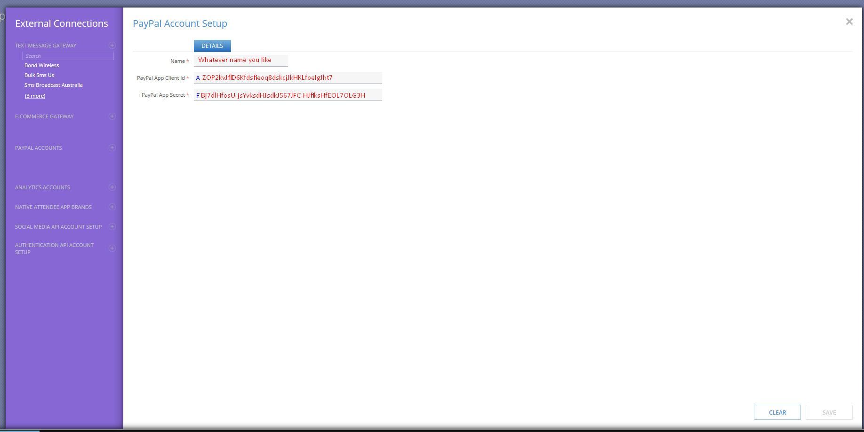

You must have an active PayPal account.

<https://developer.paypal.com/developer/applications/>

Using the link above you are required to login to your paypal account.

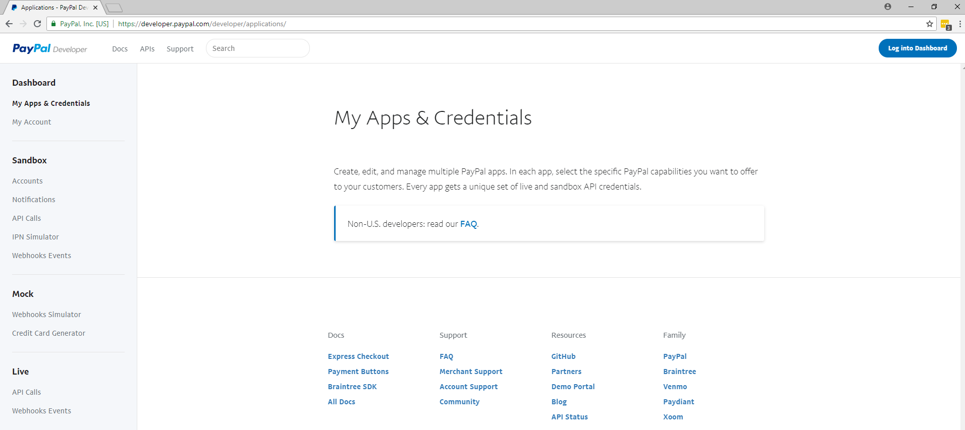

You will need to first make an App & Credential. You will be able to find this link on the Left Bar Under Dashboard > My Apps & Credential

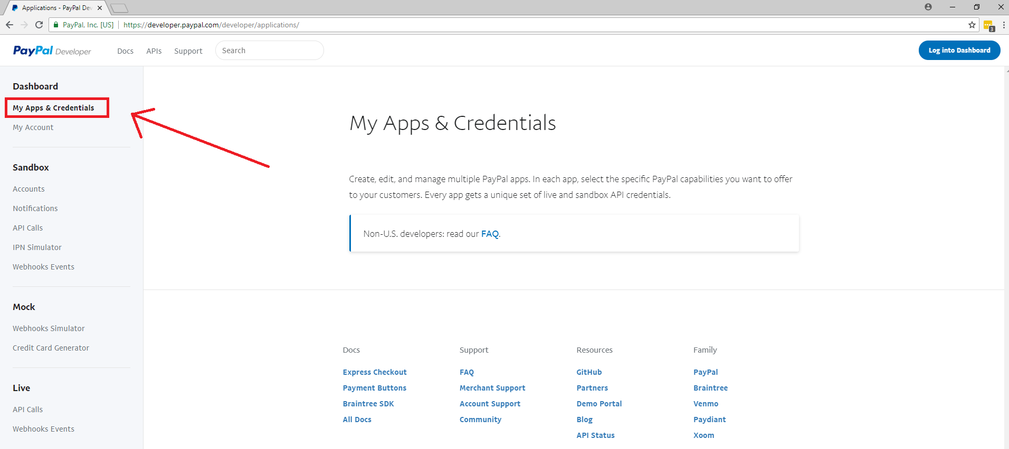

You will need to start with creating a Live Account, this should be the email you use for PayPal.  
Ensure it is set as Live,

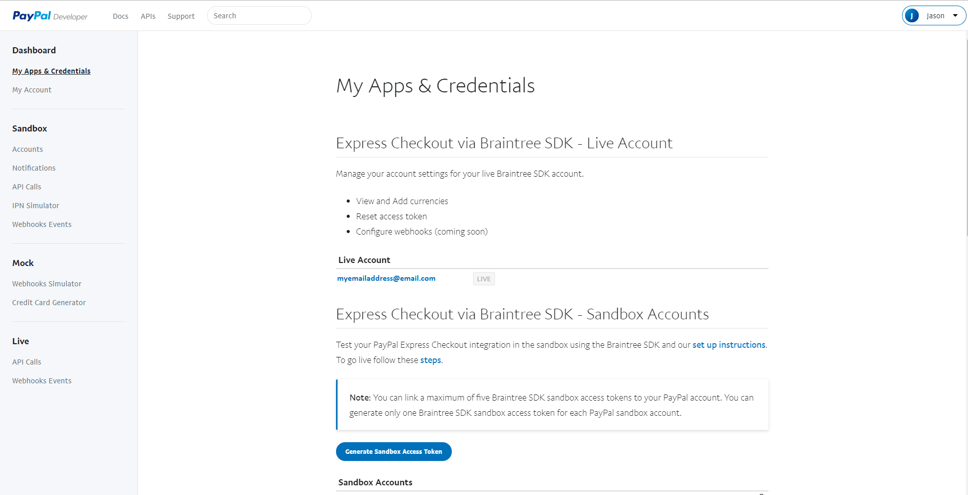

After this, scroll down you will need to create a “Rest API apps”. Click on the button “Create App”.

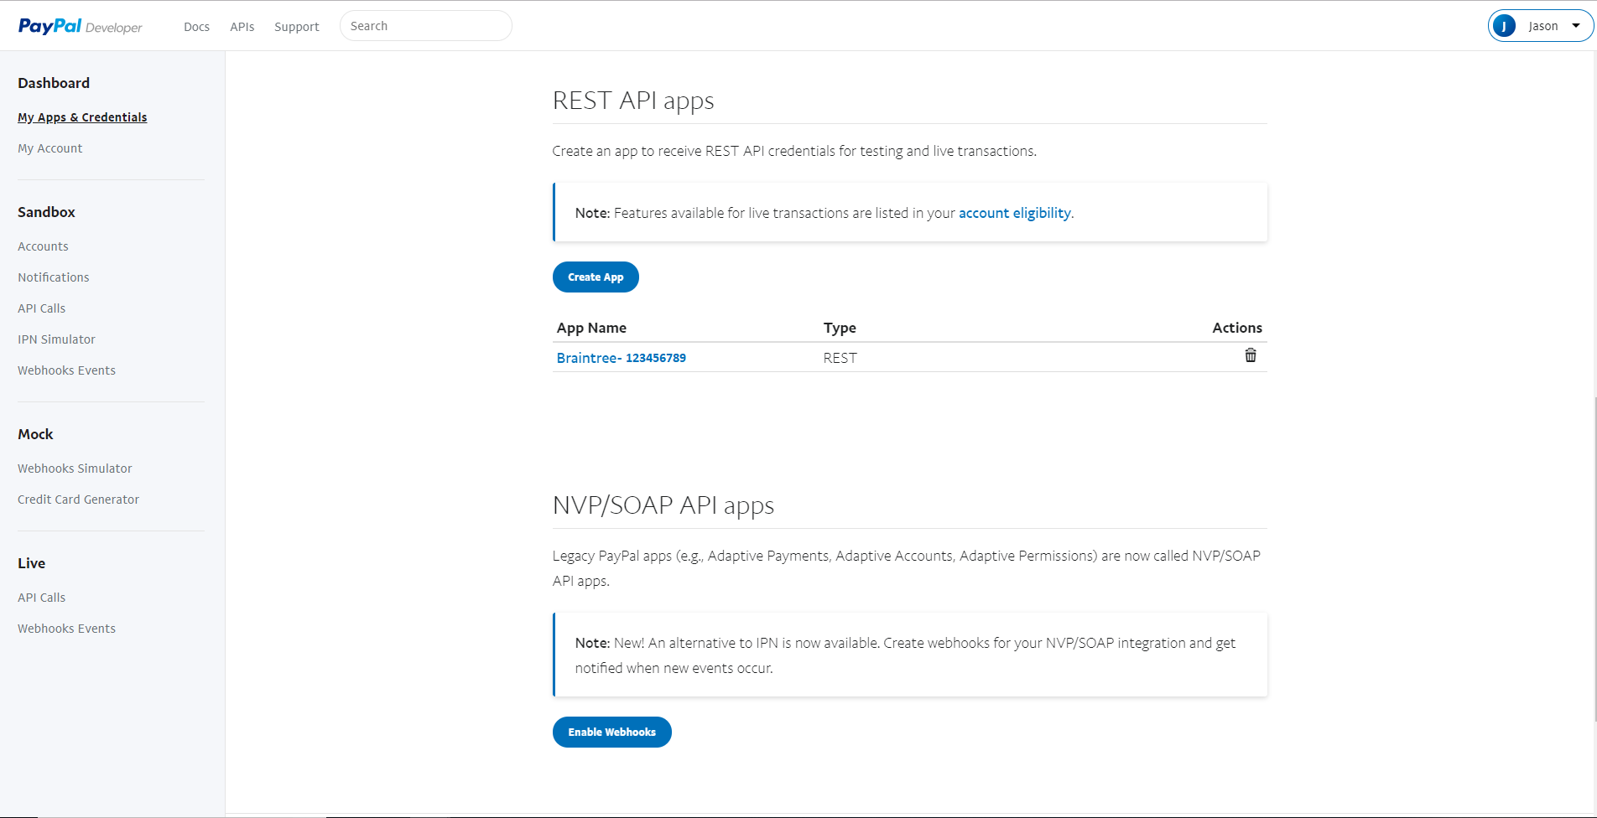

You will add the email account you set in the “Live Account”. This will provide the Client ID and App Secret. Copy and paste the Client ID into your EventsAIR.

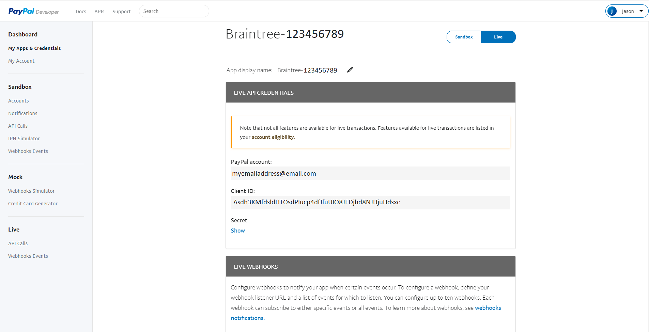

Then press on Show which will reveal the secret

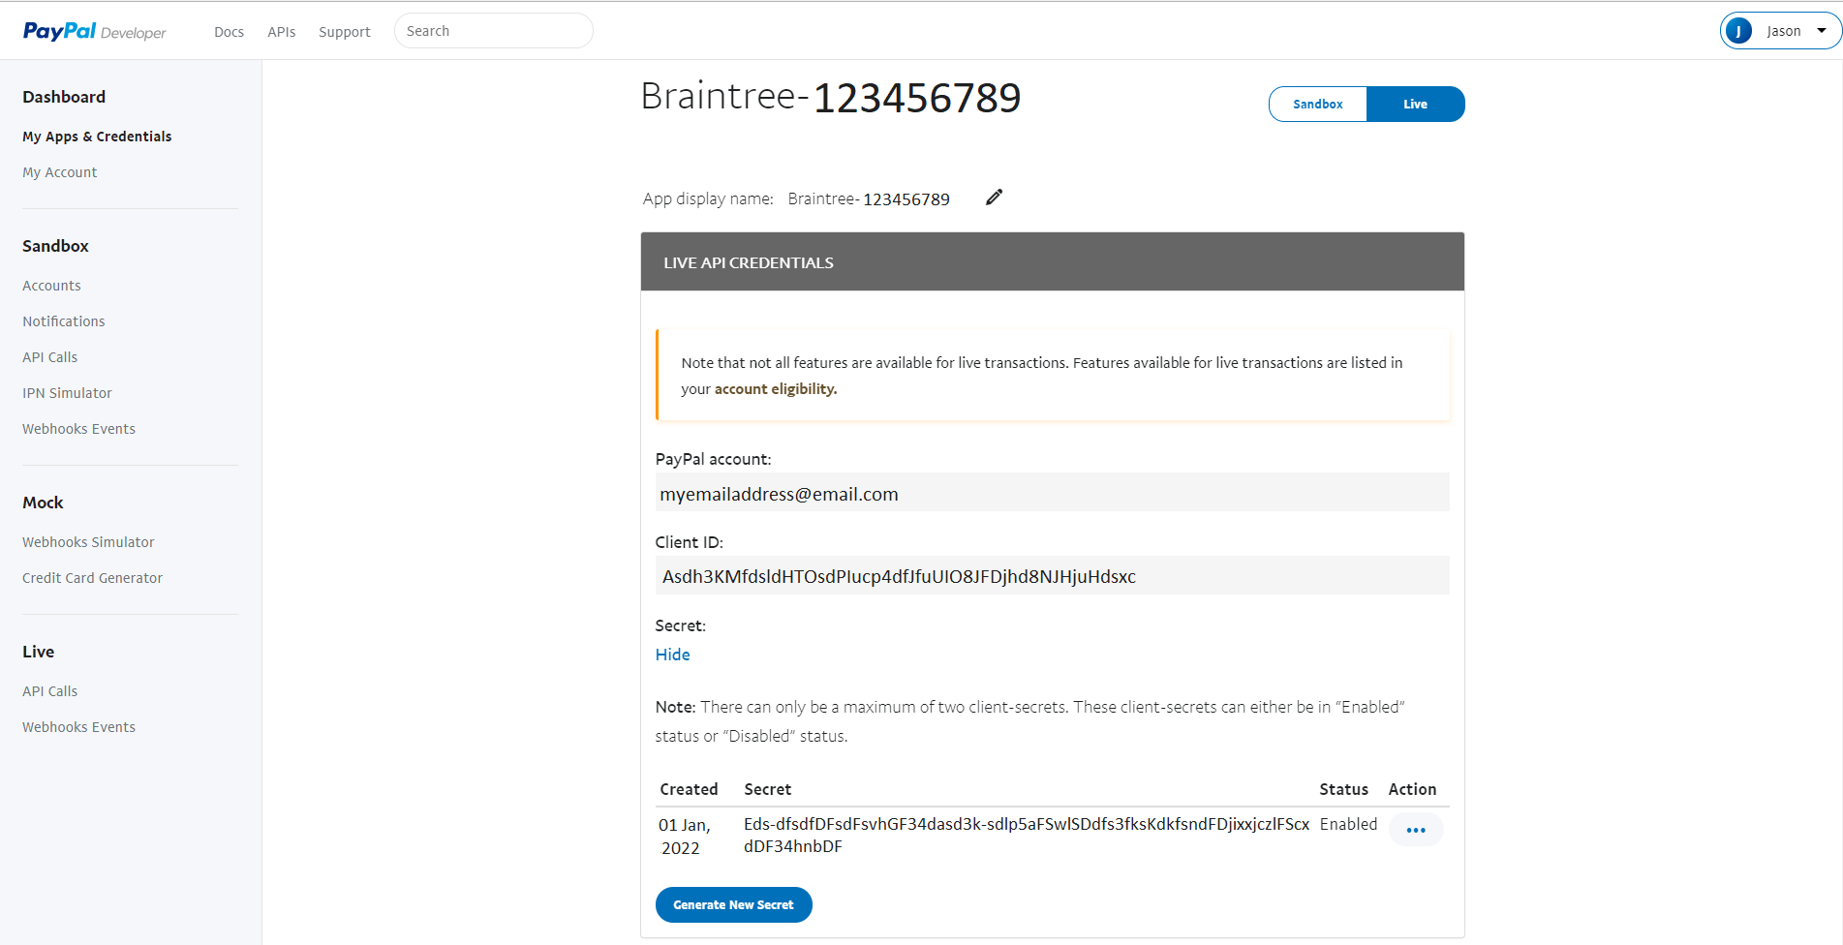

This image is the same as the start, it displays how your PayPal information look if correct (in black font)



After making your PayPal account don’t forget to add it to your event and fincanel types. To add this to your event you will find this in Event > Event Preferences > External Connections > PayPal Account.

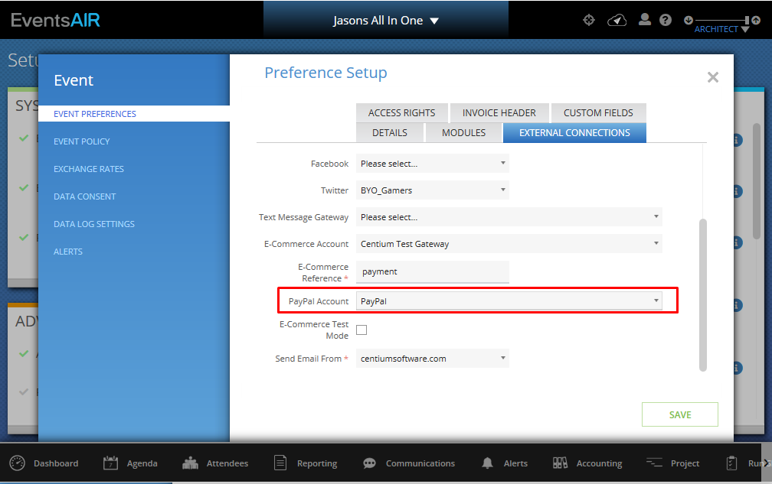

After adding the PayPal account go to **Financial** which is in **Setup** and create a new payment type. You will now have the option to add Funding Type “PayPal”

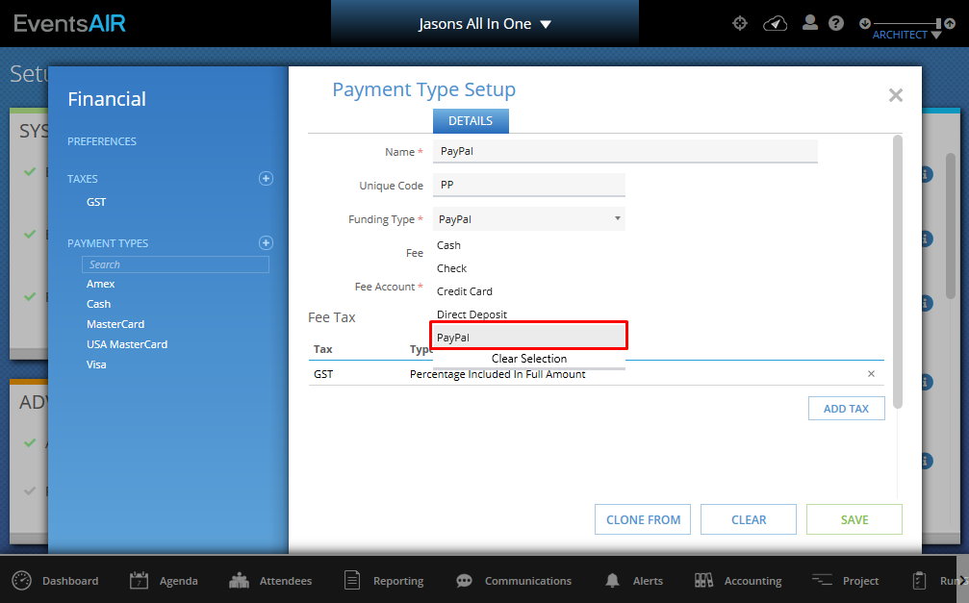

To enable this option for registration you will need to go into your registration site. Under the Payment Page Module, you will need to check the PayPal option.

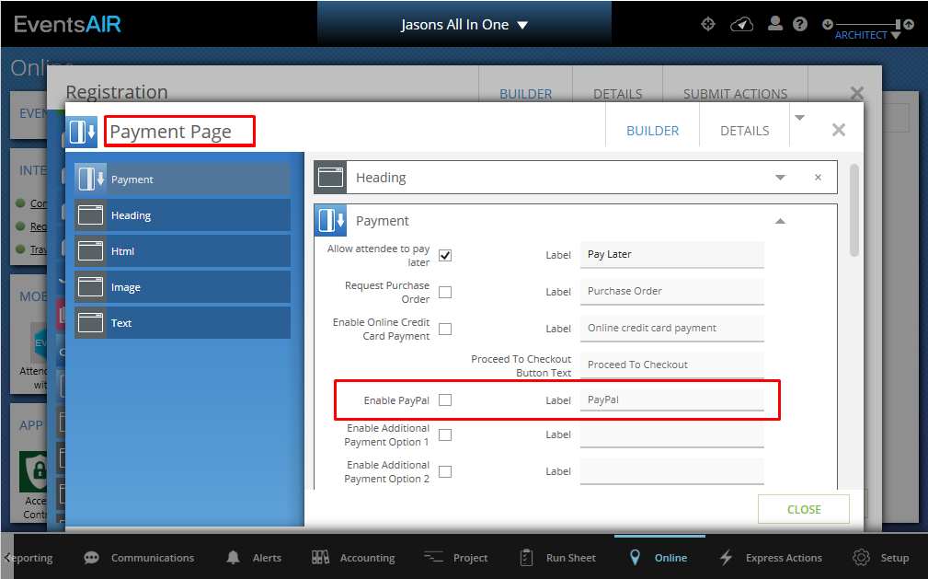

This completes all stages of creating a PayPal account and setup to be used in EventsAIR.